Hierarchical Classification Approach to Fall Detection

Nalinadevi K, Nishita Dash, Harshavardhini B, Adithya P Varma¹
¹Department of Computer Science and Engineering
Amrita School of Computing, Coimbatore
Amrita Vishwa Vidyapeetham, India
k_nalinadevi@cb.amrita.edu
cb.en.u4cse18037@cb.students.amrita.edu
cb.en.u4cse18021@cb.students.amrita.edu
cb.en.u4cse18105@cb.students.amrita.edu

Article Info |  | ABSTRACT
Article history:  Received month dd, yyyy  Revised month dd, yyyy  Accepted month dd, yyyy |  | Falls are the main cause of morbidity and disability in the elderly. A general study revealed that more than 1 million cases per year are reported for Parkinson's disease. By 2030, it is expected to rise to 1.2 million cases. Due to instability, a huge proportion of Parkinson's patients have been facing recurrent falls. Compactness of the motion sensors makes smartphones a better choice for collection of data among all other wearable sensors. Usage of smartphone sensors enables accurate and precise collection of data for various types of fall like - side fall, backward fall and forward fall. A major challenge in fall detection includes achieving shorter response times. This raises the need for a machine learning model with significant accuracy and lesser training time. Hierarchical classification is one such classifier that predicts multi-class labels over a predefined taxonomy. This being a less resource intensive model can be run locally on a smartphone to predict falls.Hierarchical classifiers produced an accuracy of 92% against an LSTM classifier, which produced an accuracy of only 86%.
Keywords:
Hierarchical classifier
Fall detection
Local classifier per parent node
Machine learning
Smartphone
This is an open access article under the CC BY-SA license.

Corresponding Author:
Nalinadevi K
Department of Computer Science and Engineering, Amrita School of Engineering, Coimbatore, Amrita Vishwa Vidyapeetham, India
Email: k_nalinadevi@cb.amrita.edu

- INTRODUCTION
Globally, falls among the elderly is a primary public health problem. Falling is among the most damaging events elderly people may experience. It goes without saying that not only do the injuries caused by falls experienced by elderly people have considerable consequences to their families, but they also affect healthcare systems and the society at large. This provokes the need for a device that can sense the event of a fall and immediately take action to prevent any injuries. So the proposed system is an inflatable airbag coupled with sensors that can deploy the airbags as soon as it detects a fall. The device can be worn as a hip band, with all the components placed inside.
Hsieh et al. (2017) has proposed a threshold-based multi-phase model for fall detection. The model divides the process into 3 phases: free fall, impact and rest; and sets a threshold to discriminate between falls and activities of daily life when the peak values are below or above the threshold. These thresholds are determined by the body’s experience while falling, but fixed thresholds are not applicable to all actions in a person’s daily life. According to the model, it is ideal to wear a fall sensor on the trunk. The model, however, lacks the ability to detect different types of falls.
The hierarchical machine learning model for the proposed problem can differentiate between types of falls, which can range from backward fall, front fall, or sideward fall. Identifying the type of fall could be used in the future to determine which set of airbags are to be inflated. The data required for training the machine learning model is collected using mobile application sensors. In the feature engineering stage, the raw time-series data collected from the sensors is transformed into fixed overlapping windows. The data in the fixed overlapping window is used to train the machine learning hierarchical classifier using the local classifier per parent node of the top-down approach.
The model is tested using different algorithms like the LSTM, XGBoost, and hierarchical classification. It shows that XGBoost has better results for parameters like precision, recall, and f1-score when compared to LSTM and hierarchical classification. But XGBoost takes extensive time for training and testing hence compared to all models hierarchical classification performs better in terms of the time taken to perform the testing and training, this makes the hierarchical classification a better model for the fall prediction problems.
This paper is organized as follows: Section 1 provides a detailed literature survey of recent advancements in this area of study. Section 2 provides the architecture of the proposed system and; a detailed explanation of the hierarchical classification and design of the class taxonomy. Section 3 depicts the implementation of the algorithm. Section 4 discusses the result of algorithms for each activity and also discusses the future of the algorithm. The proposed method is concluded in Section 5.

- LITERATURE SURVEY:

Three essential factors to be considered for the design of a fall detection system include the choice of sensors used to collect data, data processing techniques, and machine learning algorithms used. Three types of sensors can be used for data collection, namely wearable sensors, vision-based sensors, and ambient sensors. Usage of vision-based sensors involves monitoring the concerned subjects and their movements. A deep learning approach is widely used to detect falls from the captured images. Lin et al. (2021) is one such existing work that solves this problem using OpenPose technology. Sree and Jeyakumar (2019) is another work that does a posture and shapes analysis on the recorded images. Vadivelu et al. (2016) uses thermal image processing for detecting fall from the captured images. However, it is observed that the usage of vision-based sensors increases the processing load and response time. The vision-based methodology does not consider the parameters for monitoring. This problem requires quick actions to be taken in response to the detected fall. Hence a wearable sensor is required for quicker processing. The same has been highlighted in Ramachandran and Karuppiah (2020). Mrozek et al. (2020), Wu et al. (2015), Lee et al. (2018), Kowshik et al. (2020), Megalingam et al. (2012) are some of the existing works using wearable sensors. Wearable sensors have proven to be efficient in monitoring various parameters as they are person-related and direct sensors. The accelerometer and gyroscope have been proved as efficient sensors required for monitoring and detecting human daily life activities. The proposed work uses smartphone sensors for data collection.
After collecting raw data, feature extraction is essential to apply ML techniques. Dataset:2010 and Dataset:2013 are some of the two existing datasets that collect sensor data for daily life activities from multiple subjects and calculate various central tendency measures like mean, standard deviation as part of the pre-processing step.The existing open-source dataset for human activity recognition does not consider falls or
various types of falls as a human activity. The proposed work includes data collection for different fall activities and derives inspiration from the windowing technique used in the existing open-source datasets for feature engineering.
Once feature engineering is applied, many of the existing systems apply two of the following techniques, namely threshold-based techniques and machine-learning-based techniques. Wang et al. (2018), Lee and Tseng (2019) are some of the recent studies on threshold-based fall detection systems. The need is to detect pre-impact falls. Threshold-based techniques are not efficient in predicting falls before their occurrence. The problem of detecting a fall is considered a multi-class classification problem. Vallabh et al. (2016) uses KNN for detecting falls. They achieve an accuracy of 87.5 using KNN models. The accuracy of weak classifiers is improved by using an ensemble of classifiers. Yacchirema et al. (2019), Hussain et al. (2019) are some existing works on Ensemble techniques to solve this problem. In spite of achieving very good accuracy, the problem is the time and space consumed by such methods. Techniques like ensemble classifiers are a time and space expensive method. The same issue is faced with models like neural networks. Yoo and Oh (2018) is an existing solution that uses an artificial neural network deep learning-based approach and achieves an accuracy of 100 with a wrist accelerometer sensor. But such heavy load processing in portable devices adds to the cost of the system. It increases the response time which is an essential factor when integrated with the fall protection device. Hence for practical applications like fall detection systems, we need a lightweight machine learning model that can minimize the training, testing, and response time.
Hierarchical classification is an interesting approach to solve multi-class classification problems. The hierarchical classifier is a structured classification approach that predicts the classes over a hierarchical structure.Wu et al. (2019) is an existing system that uses the hierarchical classification for fall detection. It predicts non-fall, forward fall, and backward fall for each of the human activities. The proposed work draws inspiration from the above work for solving the problem. A significant distinction from the existing work is that the proposed work considers the nature of human activity based on the accelerometer and gyroscope values. The meta-classes are defined owing to the nature of the activities so as to design a robust methodology that covers edge-cases and avoids interpretations. Further sections of the paper discusses the hierarchical classification approach to this problem in a systematic manner.

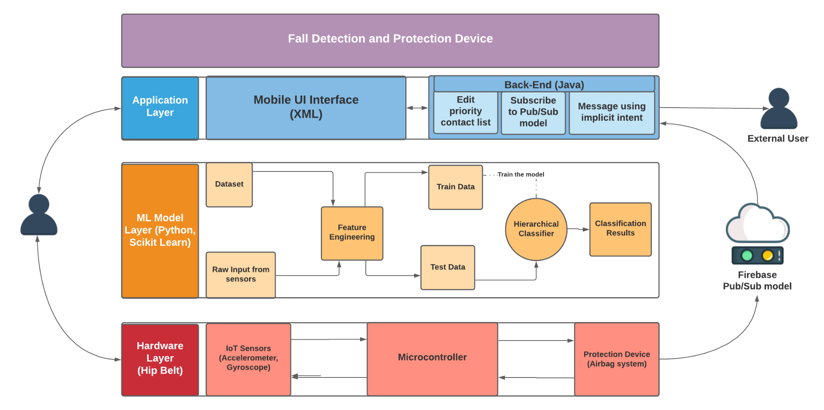
- PROPOSED SYSTEM AND RESULTS

3.1. Architecture Diagram

Figure 2.1: Architecture Diagram

3.2. Algorithm

Fall is an involuntary human activity. On a broader perspective, the problem of detecting a fall is to identify fall among the various other daily life activities like walking, running, standing. Hence, human daily life activity recognition problem is a multi-class classification problem. The literature study suggests various methods to solve the multi-class classification problem which includes neural networks, ensembles. This paper addresses the hierarchical classification approach to solve this problem. This algorithm is chosen as the optimal approach for this problem as it achieves a significant accuracy with less load on training and testing phase unlike other load-expensive models like ensembles and neural networks.

3.2.1 Hierarchical Classification

Many of the real world classification problems have an inbuilt hierarchy among the classes to be predicted. The hierarchical classification is predicting classes over a structured class taxonomy. The class taxonomy is generally a DAG or a tree. There are various measures to be addressed for design and implementation of the hierarchical classifiers Silla and Freitas (2011):
• Design of class taxonomy
• Way of exploring the taxonomy
• Depth of classification over the taxonomy

3.2.2 Design of Class Taxonomy
Class taxonomy is defined as tree structure over a partially defined over class concept hierarchy (C, ≺), where C is a set of classes in the application domain and ≺is IS-A relationship. Silla and Freitas (2011) The class taxonomy defined should be either a DAG or a tree with no loops. The IS-A relationship should satisfy the Anti-reflexivity, Anti-symmetric and Transitivity criteria.

Class Taxonomy for Human Activity Recognition

The commonly identified human activities include standing, sitting, walking, running, jumping, lying down, bending. However as discussed earlier the fall is also a type of human activity. This paper addresses the problem of identifying fall at a micro level which include side fall, backward fall, forward fall. The need for this micro-level classification is realized when designing the protection device for a fall detection system.
There are certain edge-cases that need to be considered for the design of the algorithm. Activities like getting up fast shows a sudden spike in The design of class taxonomy necessitates to identify meta-classes. From the above identified classes and its analysis, it can be inferred that activities like Standing, Sitting are activities with less or no change in the accelerometer and gyroscope values over a period of time. Hence these three activities form the sub-classes of the meta class that is the static postures. The remaining activities fall under the category of dynamic postures. However, on observing the graphs for activities like walking, running and continuous jumping there is a constant change in accelerometer and gyroscope values. Hence these activities fall under the meta-category, constant change transitions and the remaining activities fall under the short lived transitions category as there is a sudden spike in the accelerometer and gyroscope values. The side fall, backward fall and forward fall are grouped under the meta-class Fall. For the fall detection problem, the taxonomy is represented as following -

• Root of the taxonomy, R – Activity
• C is set of classes that represents the human activities including standing, sitting, walking, running, continuous jumping, side fall, backward fall, bending, getting up fast
• Set of meta-classes which include static postures, dynamic postures, constant change, short lived transitions, fall

The fig.3.2 diagram depicts the class taxonomy designed for the fall detection problem. The taxonomy satisfies the IS-A relationship criteria.
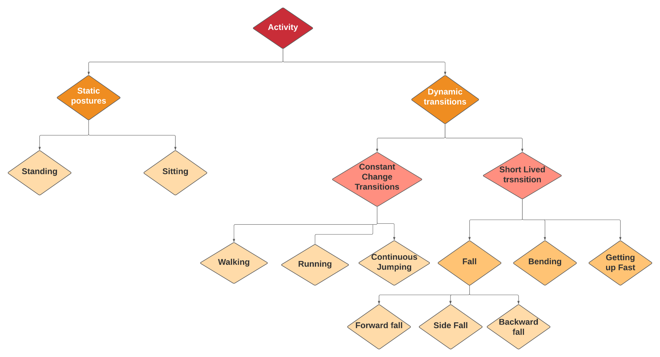
Figure 2.2: Class Taxonomy

3.2.3 Way of exploring the Taxonomy
There are two ways of exploring the taxonomy Silla and Freitas (2011) -
- Top-down approach (local classifiers). This method deploys local classifiers for every node in the class hierarchy graph. There are three further sub-classifications
– Local classifier per node
– Local classifier per parent node
– Local classifier per level
- Bottom-up approach (global classifiers). Top-down classifiers are an easier approach to implement hierarchical classification. The leaf node of the taxonomy represents the classes to be predicted. Hence given an activity, a top-down approach is an efficient method to classify human activity. This paper addresses the implementation of hierarchical classifiers using local classifiers per parent node. The reason for choosing LCPN is that the designed taxonomy does not require a binary classifier at the leaf node. A multi-class classifier at the parent node serves the purpose. A per-level classifier is not an efficient method. This is because there is a possibility of getting different results for each level of the classifier. For the given taxonomy, it would produce insignificant and uncorrelated results. This would require post-processing techniques to handle the prediction inconsistency at each level. Hence LCPN is a robust approach for the designed taxonomy.

3.2.4 Depth of Classification over the Taxonomy
It is possible to implement hierarchical classification either as mandatory leaf node prediction (MLNP) or as non-mandatory leaf node prediction (NMLNP) Silla and Freitas (2011). The former category of hierarchical classification predicts till the leaf node is reached. The latter might stop at any level of the tree or DAG structure. The proposed work acts at the micro level considering the different possibilities of fall. This particular problem requires us to identify the human activity to avoid edge-cases. Given that human activities form the leaf nodes of the tree, a mandatory leaf node prediction is essential.

To summarize, the hierarchical categorization problem is represented using a 3 Tuple Representation - where

- T is the taxonomy
- SPL stands for Single Path Label, as each class is a short or fixed activity pattern
- FD stands for Full Depth labeling for identifying the meta-classes.
The approach for the hierarchical classifier design is represented using a 4-tuple representation - [< 4, Σ, Ω, Θ > ]

- △ uses Single Path Prediction
- Σ represents depth of classification over taxonomy. MLNP is used in the current context.
- Ω represents the taxonomy used.
- Θ is the categorization of the algorithm. LCPN is used in the proposed work.

Implementation

Dataset
It is an in-house data collection where the data is collected using mobile application sensors. The accelerometer and gyroscope readings for all activities like back-fall, bending, front fall, getting up fast, jumping, running, side fall, sitting, standing, walking is collected to train the model for fall detection. A total of 7000 records are collected for each activity. This raw time-series data is cleaned and preprocessed. In comparison with other public datasets this dataset has records for daily life activities and also for
different types of falls.

Feature Engineering
The data collected using the mobile application sensors is raw time series data and standard classification algorithms cannot be directly applied on this data. Hence the raw time-series data is transformed using a data transformation technique called the ‘windowing’ technique. In this technique, the data is divided into windows of 50 records. Idea behind setting the window size to 50 records is that too less window-size may not capture the motion correctly, while too large window-size results in less data points in transformed dataset for training. Instead of taking discrete windows, overlapping windows with 50 percent overlap is considered. This ensures that every subsequent row in the transformed data-set has some information from the data in the previous window as well. New features are then being generated by aggregating the 100 raw samples contained within each of the windows of 50 records. For assigning class-label for the transformed features, the most frequent activity in that window is assigned. In the feature engineering step for the data collected, the raw signal data of the smartphone accelerometer and gyroscope is transformed, and new features are created from it for identifying common human activities. The data is split into testing and
training data sets. After splitting the data, feature engineering is performed in stages:

Stage 1: statistical measures
In this statistical measures like mean, standard deviation, average absolute deviation, minimum value, maximum value, difference of maximum and minimum values, median, median absolute deviation, interquartile range, negative values, count, positive values count, number of values above mean, number of peaks, skewness, kurtosis, energy, average resultant acceleration, signal magnitude area are calculated. The new data frame is used, and progressively new features are added to it, and eventually used for training machine learning models. The fast Fourier transformation is a function that takes in a time signal as input and outputs the frequency representation of the signal in response.
Stage 2: capturing indices
The main goal of the feature engineering stage in any machine learning problem is to provide as much possible information to the model. The min and max index values of the underlying data are considered potential features. In this stage, raw test data frame is transformed and features are extracted from it to build the transformed test dataset.
Stage 3: Algorithm Implementation
The hierarchical classification is implemented using the scikit-learn library. The library module requires two essential parameters for the implementation of the hierarchical classification are
• Class taxonomy is the designed class taxonomy that is fed to the classifier object in the form of a dictionary.
• Pipeline of local classifiers is a pipeline of Support Vector Machine(SVM)Cortes and Vapnik (1995) classifiers that have been used.

Here it can be observed that a pipeline of classifiers is required. The reason for solving this problem using hierarchical classification is that we could achieve better accuracy with a better response time. Hence we need a pipeline of linear classifiers to optimize the processing load. Among linear classifiers, SVM is a robust classifier that achieves better accuracy with sparse features and doesn’t suffer from overfitting problems. Hence SVM is an optimal choice for the linear classifier pipeline.

2.3 Results and Discussion
2.3.1 Inferences
The performance metrics used for assessing the various models are recall, precision, f1- score, and support. Precision is calculated as the fraction of the true positives by the total number of positive predictions. Recall is the measure of the fraction of true positives, in a pool of all the real positives. f1-score is the reciprocal of the mean of the reciprocals of precision and recall. The micro-averaged f-beta score is calculated, the fraction of common ancestors between the misclassified class and the actual class to the extended set of predicted classes. These are definitions as stated on the web.
These values are calculated for static activities like sitting and standing and dynamic activities like falling, walking, running, jumping, bending, and getting up fast, for LSTM model, hierarchical model and XGBoost model and the results are summarized in Tables 2.1, 2.2 and 2.3 respectively, which are given below. LSTM results work exceptionally well for the case of a side fall, as can be seen from Table 2.1, given below. But the model is not able to identify front fall very efficiently. A decent score is achieved for the case of a back fall. The average f1-score for the metaclasses using the LSTM model can be summarized as 91% for static postures, 86% for dynamic postures, 87% for constant change classes, 84% for short lived transitions and 85% for fall activities.

Activity | Precision | Recall | f1-score
backfall | 88 | 77 | 82
bending | 97 | 75 | 84
frontfall | 69 | 83 | 75
getting up fast | 96 | 72 | 82
jumping | 99 | 90 | 94
running | 88 | 82 | 85
side fall | 100 | 98 | 99
sitting | 100 | 100 | 100
standing | 69 | 100 | 82
walking | 71 | 98 | 82
accuracy |  |  | 86
macro avg | 88 | 87 | 87
weighted avg | 89 | 86 | 87

Table 2.1: LSTM result

From Table 2.2 given below, it can be seen that the hierarchical model performs exceptionally well for dynamic activities like getting up fast, jumping and running. For static activities like sitting, a score of 99% is achieved. For fall activities, although side falls are predicted accurately, the results for back fall and front fall are not good, and it makes sense as they are comparatively difficult to detect, which is evident from the results of the three models used. The average f1-score for the meta-classes using the hierarchical classification model can be summarized as 95% for static postures, 92% for dynamic postures, 95% for constant change classes, 89% for short lived transitions and 87% for fall activities.

Activity | Precision | Recall | f1-score
backfall | 84 | 88 | 86
bending | 90 | 81 | 85
frontfall | 77 | 75 | 76
getting up fast | 96 | 92 | 94
jumping | 97 | 94 | 95
running | 94 | 94 | 94
side fall | 100 | 98 | 99
sitting | 99 | 100 | 99
standing | 82 | 100 | 90
walking | 94 | 94 | 95
accuracy |  |  | 92
macro avg | 91 | 91 | 91
weighted avg | 92 | 92 | 92
Table 2.2: Hierarchical classification results
From Table 2.3, it can be seen that for static activities like sitting and standing, XGBoost performs exceptionally well with a score of 95% and above. The results for fall activities like front fall, back fall and side fall, the results are better than the hierarchical and LSTM models with scores beyond 90% in terms of precision. The average f1-score for the meta-classes using the hierarchical classification model can be summarized as 99% for static postures, 97% for dynamic postures, 97% for constant change classes, 96% for short lived transitions and 95% for fall activities.

Activity | Precision | Recall | f1-score
backfall | 92 | 96 | 94
bending | 97 | 99 | 98
frontfall | 93 | 90 | 91
getting up fast | 100 | 97 | 99
jumping | 100 | 95 | 97
running | 98 | 96 | 97
side fall | 100 | 99 | 99
sitting | 100 | 100 | 100
standing | 95 | 100 | 98
walking | 94 | 99 | 97
accuracy |  |  | 97
macro avg | 97 | 97 | 97
weighted avg | 97 | 97 | 97
Table 2.3: XGBoost results

A class-wise analysis of the results are necessary for the better understanding about the performance of two models. For dynamic activities like side fall, running and getting up fast, there is a marginal improvement for hierarchy as compared to LSTM. Theoretically, the f1-score for the meta classes can be calculated as weighted average of the f1-score of the sub-classes.
The below values show the marginal improvement in f1-score using hierarchical classifiers. The classes that are of greater importance here are dynamic postures which are predicted better using hierarchical classifiers.
While it shows that XGBoost gives a better result, there are other factors to be considered for choosing the ML model for a practical application scenario. Models like XGBoost take extensive time for training and testing. Among the linear models, LSTM is the best for multi-class classification problems. However, it is noticeable that time taken for training and testing for LSTM is higher than the one taken for hierarchical classification models. The built-in class hierarchy of the problem makes hierarchical classification a better approach for the fall prediction problem than time consuming linear models.

2.3.2 Why Flat Ensemble Fails?
The problem of detecting a fall is when it is used in real-time scenarios. Though the accuracy for the ensemble method is better, the time taken for predicting human activity is very high. This in turn increases the response time when coupled with the hardware layer. The use of flat ensemble models also requires the use of a high speed processor to get quicker results. This increases the cost and complexity of a fall detection device. Hence use of flat ensemble models for this particular problem is not practically applicable. The hierarchical classification is better considering the trade-off between the accuracy and time taken for prediction. With a significant difference in the accuracy, hierarchical classification would perform better taking the inbuilt hierarchical nature of this problem.

2.3.3 Future of Algorithm
An alternate approach for implementing hierarchical classification is by using global classifiers. The global classifiers learn the entire hierarchy at a time. The global classifier assigns classes at every level of hierarchy. The advantage of using global classifiers is that it reduces the number of classifiers to be trained. The design of the class hierarchy would have some significant changes since the classification would assign classes at each level of hierarchy.

3 Conclusion
The fall detection problem solved in this paper uses a Local Classifier Per Parent Node to address the multi-label classification problem in a decomposed manner. The selection of training is done with a balanced set of samples in each of the classes. The Local Classifier per Parent Node has proven to be an effective approach compared to the Local Classifier per Node as the usage of classifiers per node will have an overhead of extra classifiers at leaf nodes. Per level classifiers could produce inconsistent results for this particular use case. Hence, Local Classifier per Parent Node performs better than the other local classifiers with minimum error propagation. It is also an efficient approach for this application compared to linear pipeline of ensemble methods. Short duration events are better captured using this local classifier. Integrating the classifier with a protection device placed in the hip region serves as an efficient model to solve the pressing concern of the elderly people.

REFERENCES

[1] Cortes, C. and Vapnik, V. (1995). “Support-vector networks.” Machine learning, 20(3), 273–297.
[2] Hsieh, C.-Y., Liu, K.-C., Huang, C.-N., Chu, W.-C., and Chan, C.-T. (2017). “Novel hierarchical fall detection algorithm using a multiphase fall model.” Sensors, 17(2), 307.
[3] Hussain, F., Umair, M. B., Ehatisham-ul Haq, M., Pires, I. M., Valente, T. Garcia, N. M., and Pombo, N. (2019). “An efficient machine learning-based elderly fall detection algorithm.” arXiv preprint arXiv:1911.11976.
[4] Kowshik, G., Anudeep, J., Krishna, P. V., Vasudevan, S. K., and Shah, I. (2020). “An inventive and innovative system to detect fall of old aged persons–a novel attempt with iot, sensors and data analytics to prevent the post fall effects.” International Journal of Medical Engineering and Informatics, 12(1), 1–18.
[5] Lee, J.-S. and Tseng, H.-H. (2019). “Development of an enhanced threshold-based fall detection system using smartphones with built-in accelerometers.” IEEE Sensors Journal, 19(18), 8293–8302.
[6] Lee, Y., Yeh, H., Kim, K.-H., and Choi, O. (2018). “A real-time fall detection system based on the acceleration sensor of smartphone.” International Journal of Engineering Business Management, 10, 1847979017750669.
[7] Lin, C.-B., Dong, Z., Kuan, W.-K., and Huang, Y.-F. (2021). “A framework for fall detection based on openpose skeleton and lstm/gru models.” Applied Sciences, 11(1), 329.
[8] Mrozek, D., Koczur, A., and Małysiak-Mrozek, B. (2020). “Fall detection in older adults with mobile iot devices and machine learning in the cloud and on the edge.” Information Sciences, 537, 132–147.
[9] Ramachandran, A. and Karuppiah, A. (2020). “A survey on recent advances in wearable fall detection systems.” BioMed research international, 2020.
[10] Silla, C. N. and Freitas, A. A. (2011). “A survey of hierarchical classification across different application domains.” Data Mining and Knowledge Discovery, 22(1), 31–72.
[11] Sree, K. V. and Jeyakumar, G. (2019). “A computer vision based fall detection technique for home surveillance.” International Conference On Computational Vision and Bio Inspired Computing, Springer. 355–363.
[12] Vadivelu, S., Ganesan, S., Murthy, O., and Dhall, A. (2016). “Thermal imaging based elderly fall detection.” Asian Conference on Computer Vision, Springer. 541–553.
[13] Vallabh, P., Malekian, R., Ye, N., and Bogatinoska, D. C. (2016). “Fall detection using machine learning algorithms.” 2016 24th international conference on software, telecommunications and computer networks (SoftCOM), IEEE. 1–9.
[14] Wang, F.-T., Chan, H.-L., Hsu, M.-H., Lin, C.-K., Chao, P.-K., and Chang, Y.-J. (2018). “Threshold-based fall detection using a hybrid of tri-axial accelerometer and gyroscope.” Physiological measurement, 39(10), 105002.
[15] Wu, F., Zhao, H., Zhao, Y., and Zhong, H. (2015). “Development of a wearable-sensor based fall detection system.” International journal of telemedicine and applications, 2015.
[16] Wu, Y., Su, Y., Feng, R., Yu, N., and Zang, X. (2019). “Wearable-sensor-based preimpact fall detection system with a hierarchical classifier.” Measurement, 140, 283–292.
[17] Yacchirema, D., de Puga, J. S., Palau, C., and Esteve, M. (2019). “Fall detection system for elderly people using iot and ensemble machine learning algorithm.” Personal and Ubiquitous Computing, 23(5), 801–817.
[18] Yoo, S. and Oh, D. (2018). “An artificial neural network–based fall detection.” International Journal of Engineering Business Management, 10, 1847979018787905.
[19] R. K. Megalingam, D. K. M. Unnikrishnan, V. Radhakrishnan and D. C. Jacob, "HOPE: An electronic gadget for home-bound patients and elders," 2012 Annual IEEE India Conference (INDICON), 2012, pp. 1272-1277, doi: 10.1109/INDCON.2012.6420814.

